**Report “Lab 4”**

**Anton Tserakhau**

# Business analyses tasks – Dimensions

## Task 01: Create Packages for Reload Dimension from SA_*

I have created independent packages to reload dimension.

1. I have reload data to tables T_RESTAURANT_TYPES and T_RESTAURANTS with using Execute Immediate with Bind Parameters (package *pkg_etl_restaurants_dw_stage*):

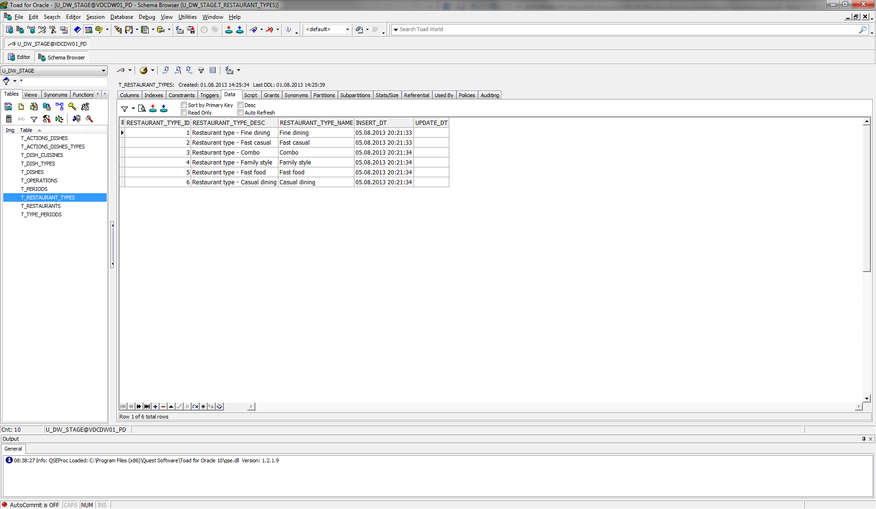

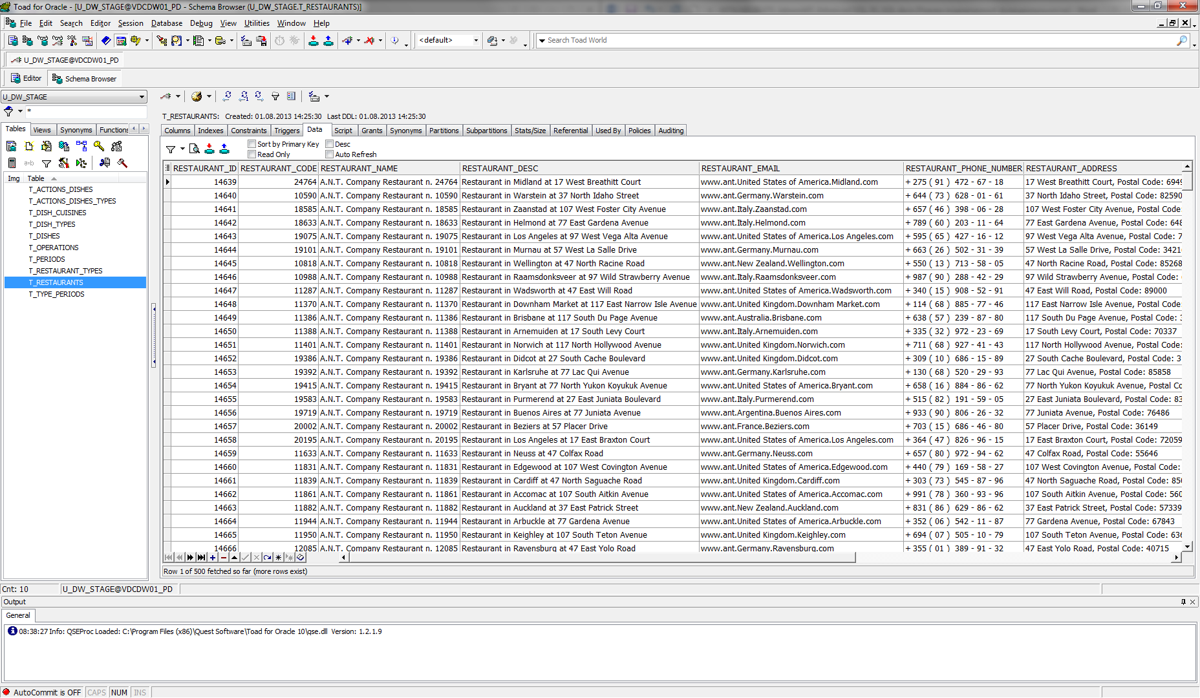

1. I have reload data to tables T_DISH_TYPES, T_DISH_CUISINES and T_DISHES with using DBMS_SQL.TO_REFCURSOR Function (package *pkg_etl_dishes_dw_stage*):

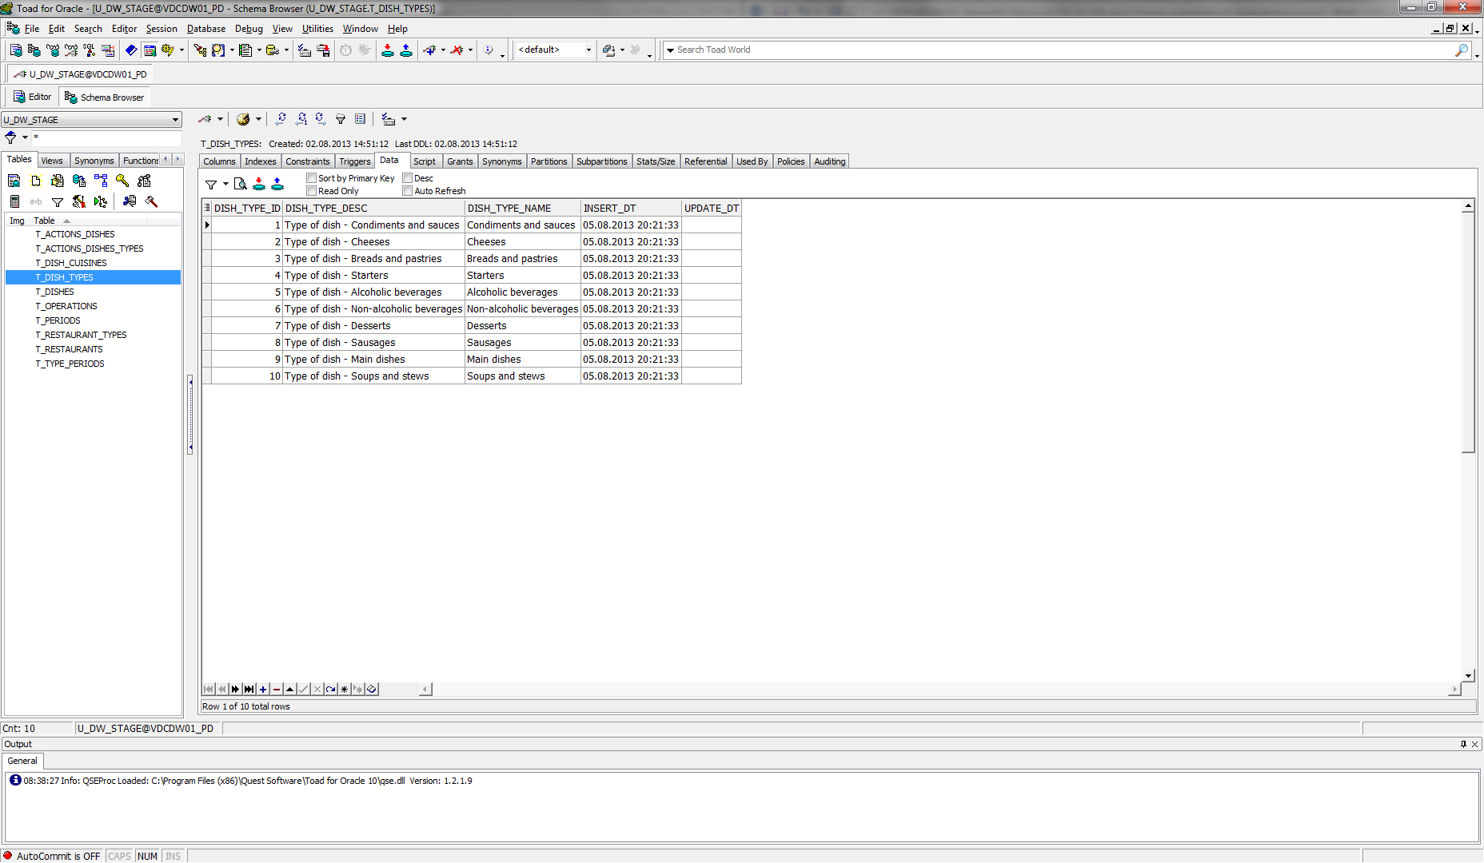

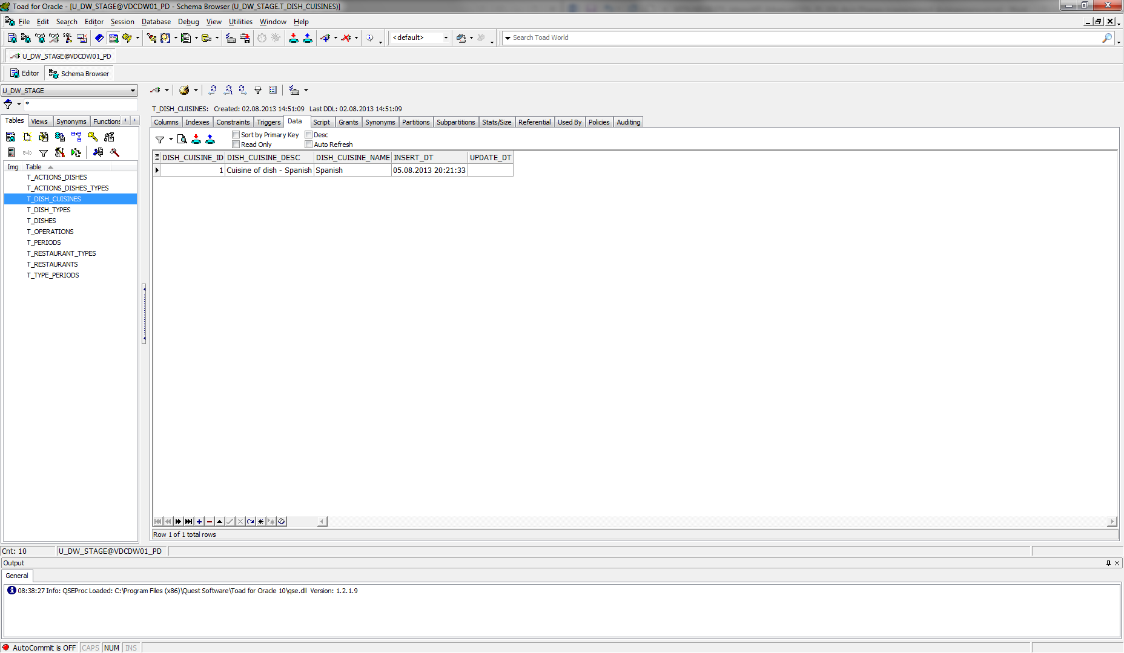

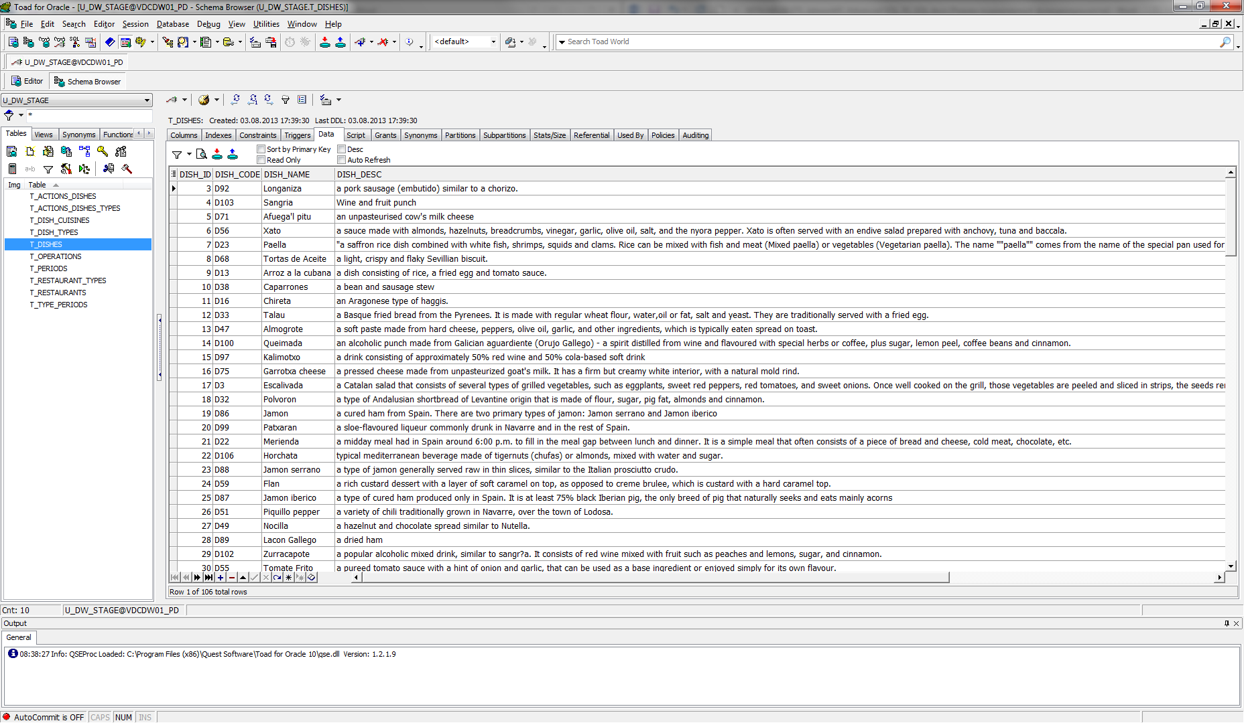

1. I have reload data to tables T_TYPE_PERIODS and T_PERIODS with using DBMS_SQL.TO_CURSOR_NUMBER Function (package *pkg_etl_periods_dw_stage*):

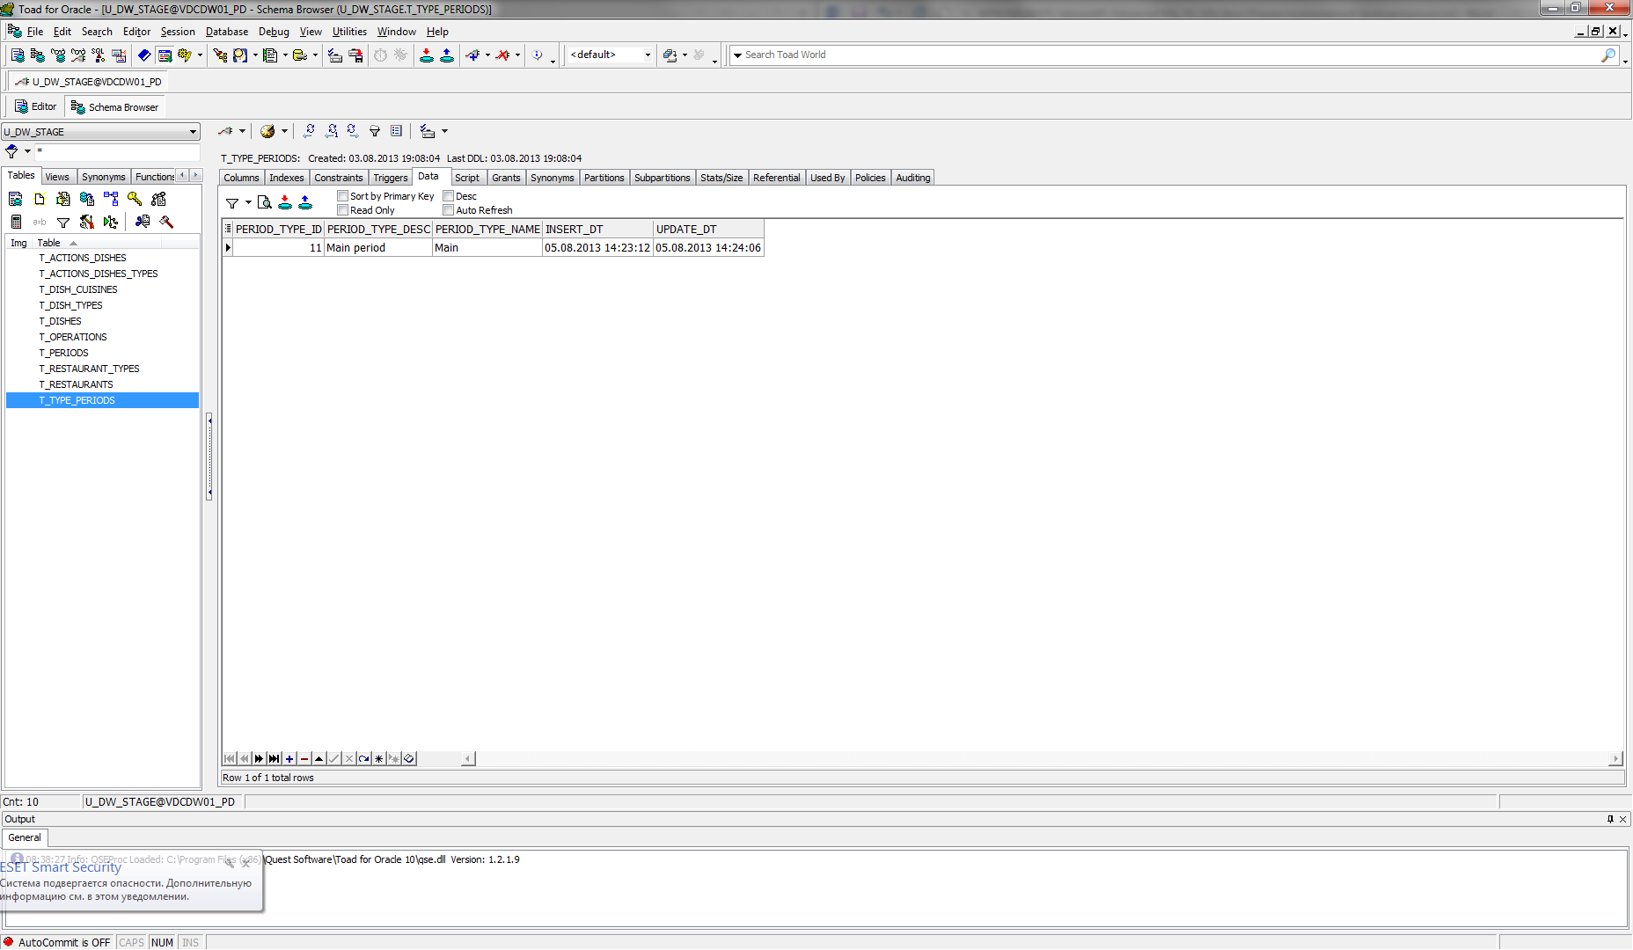

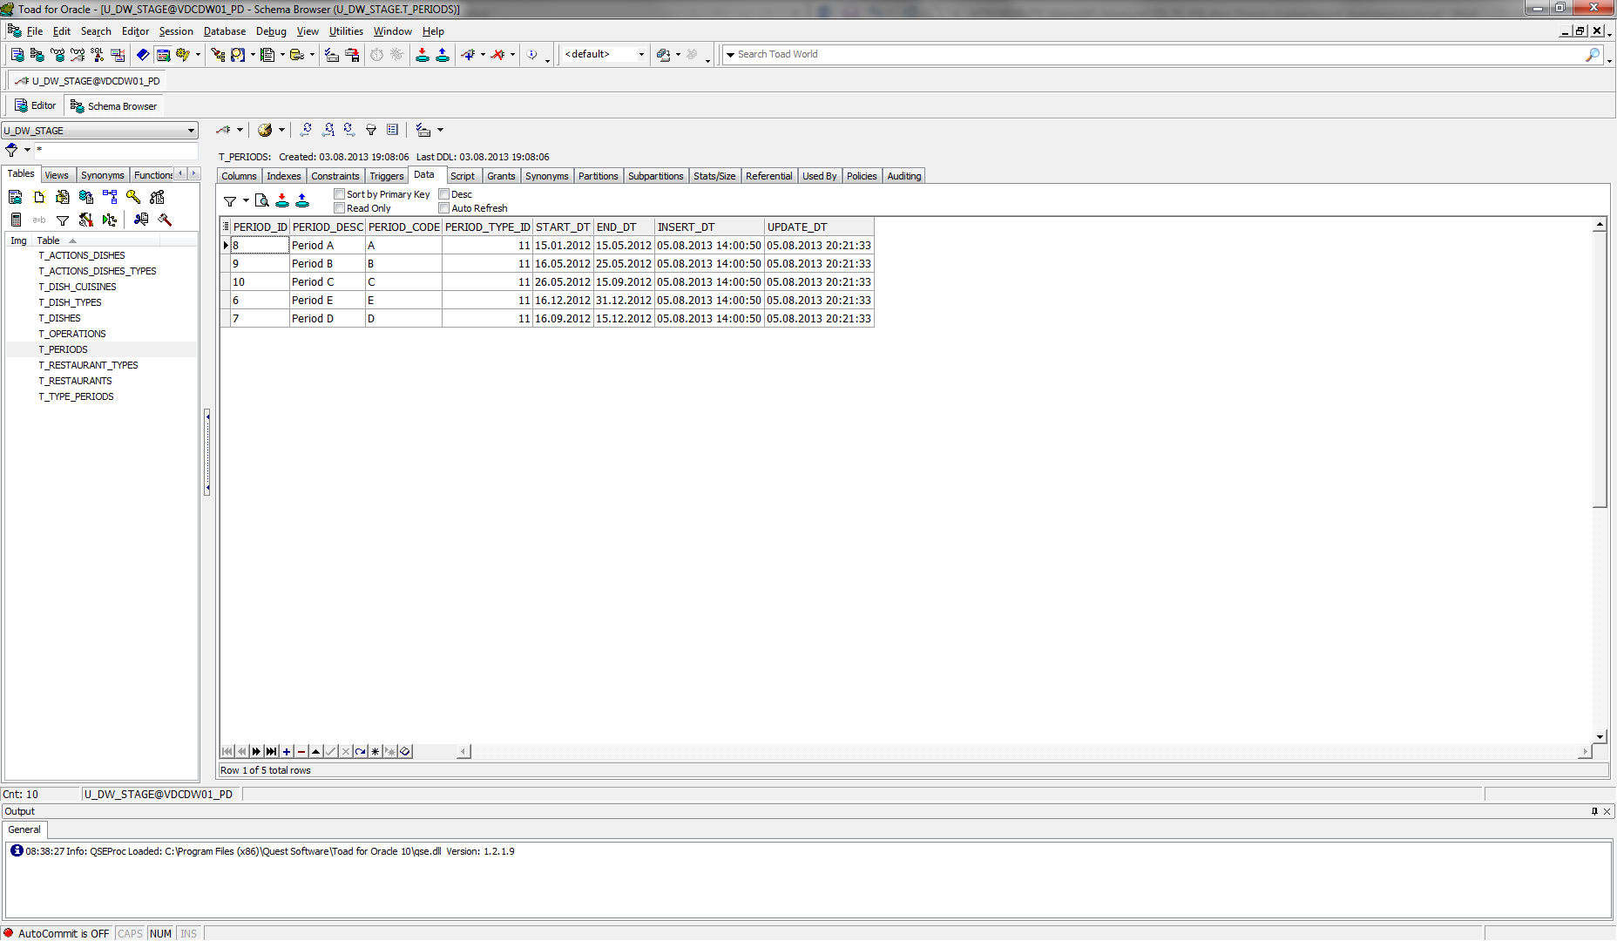

1. I have tested data for consistent. Scripts are in folder *test_data.*

Table T_DISH_CUISINES:

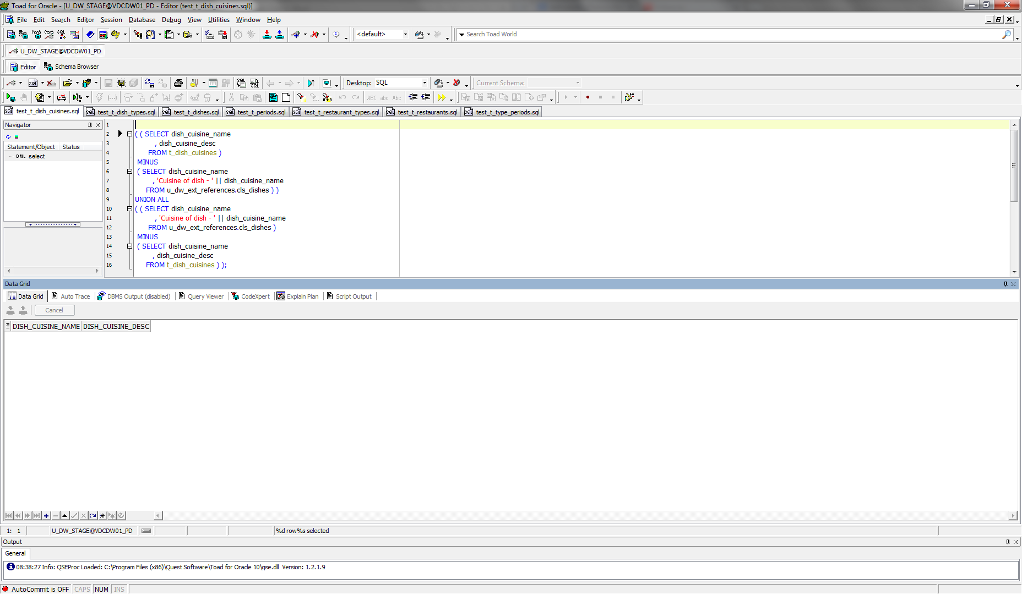

Table T_DISH_TYPES:

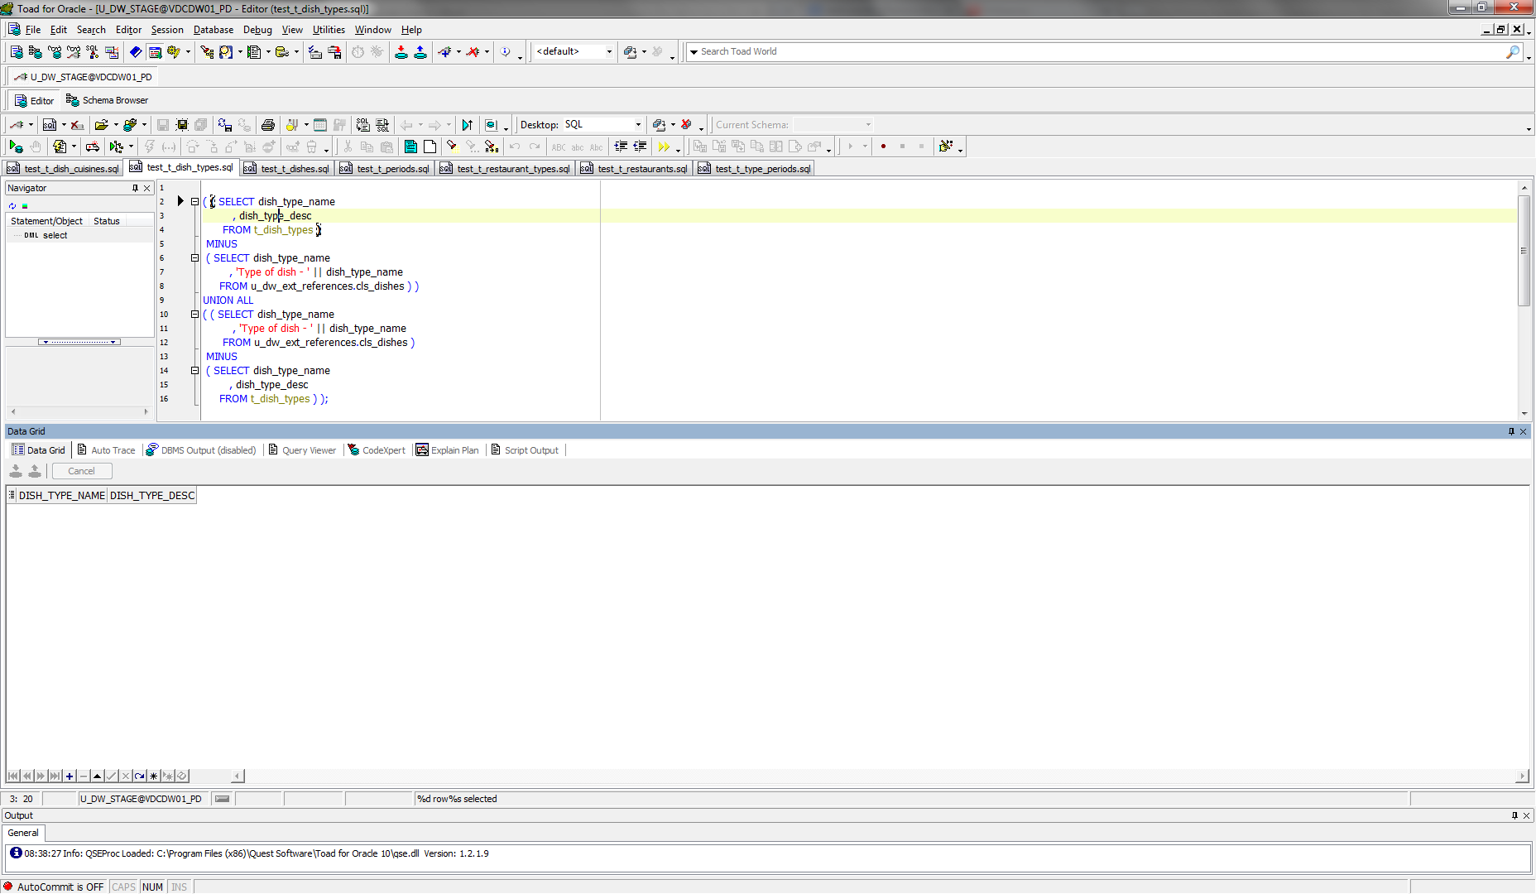

Table T_DISHES:

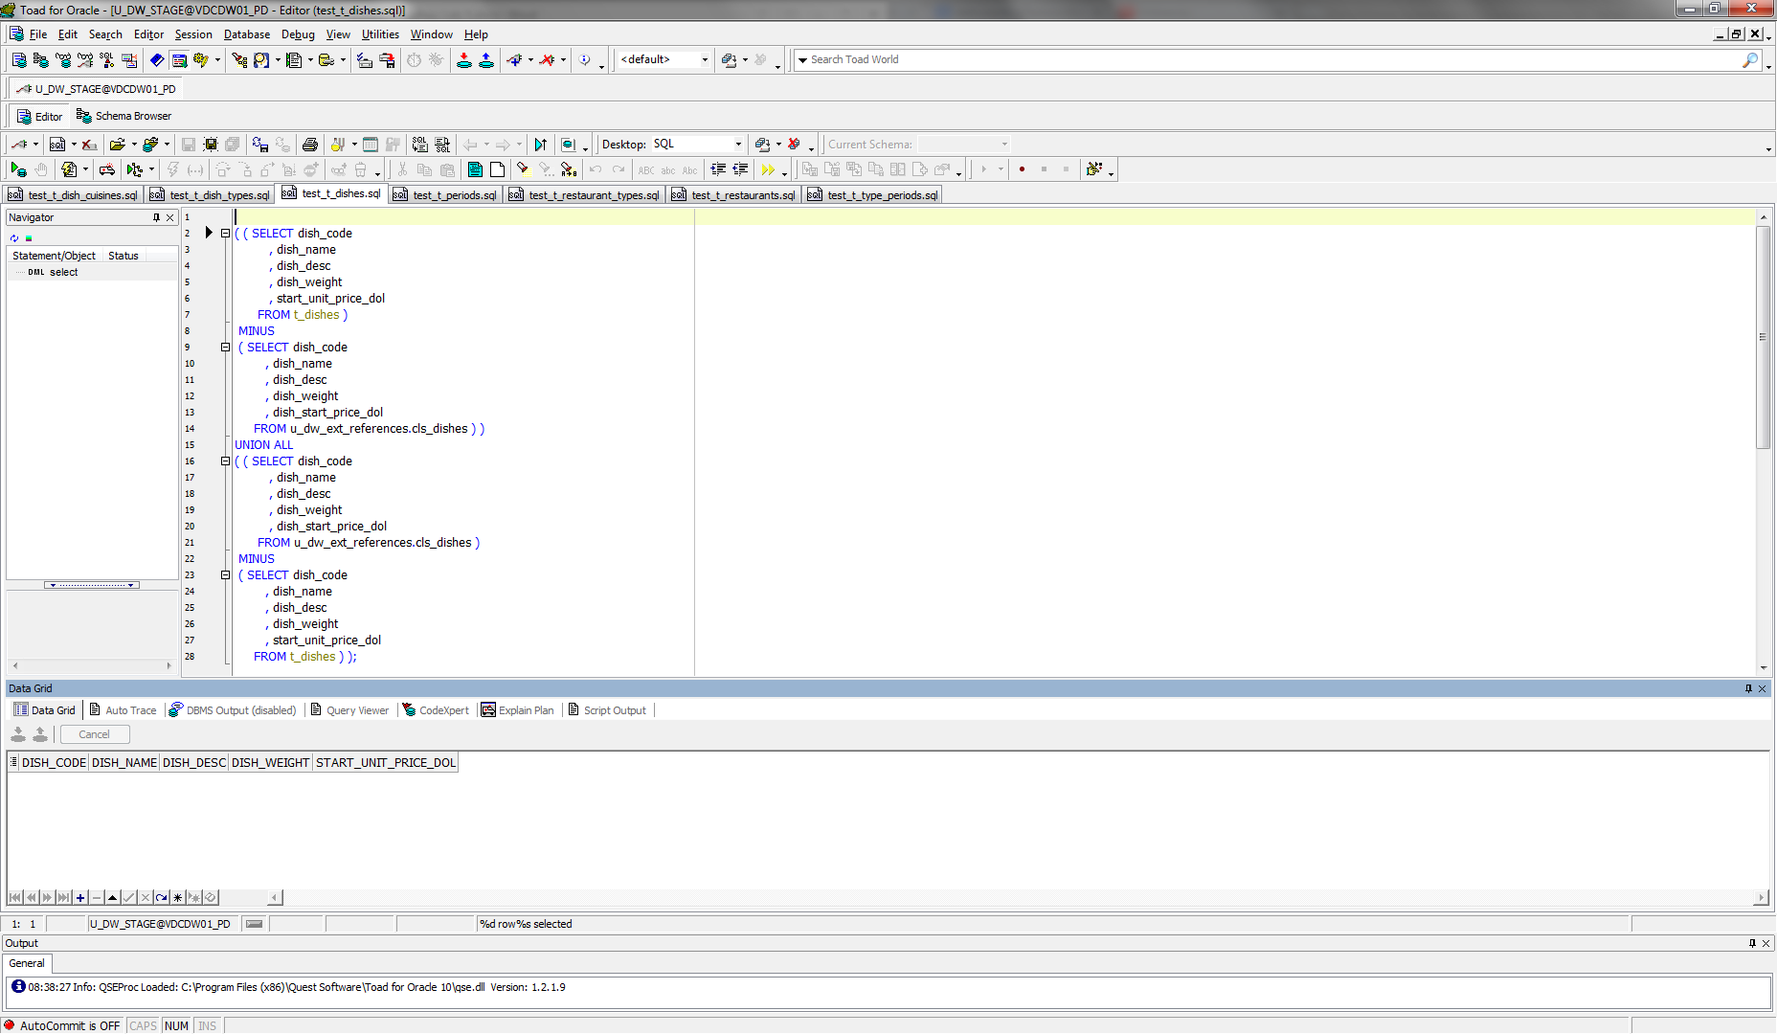

Table T_OPERATIONS:

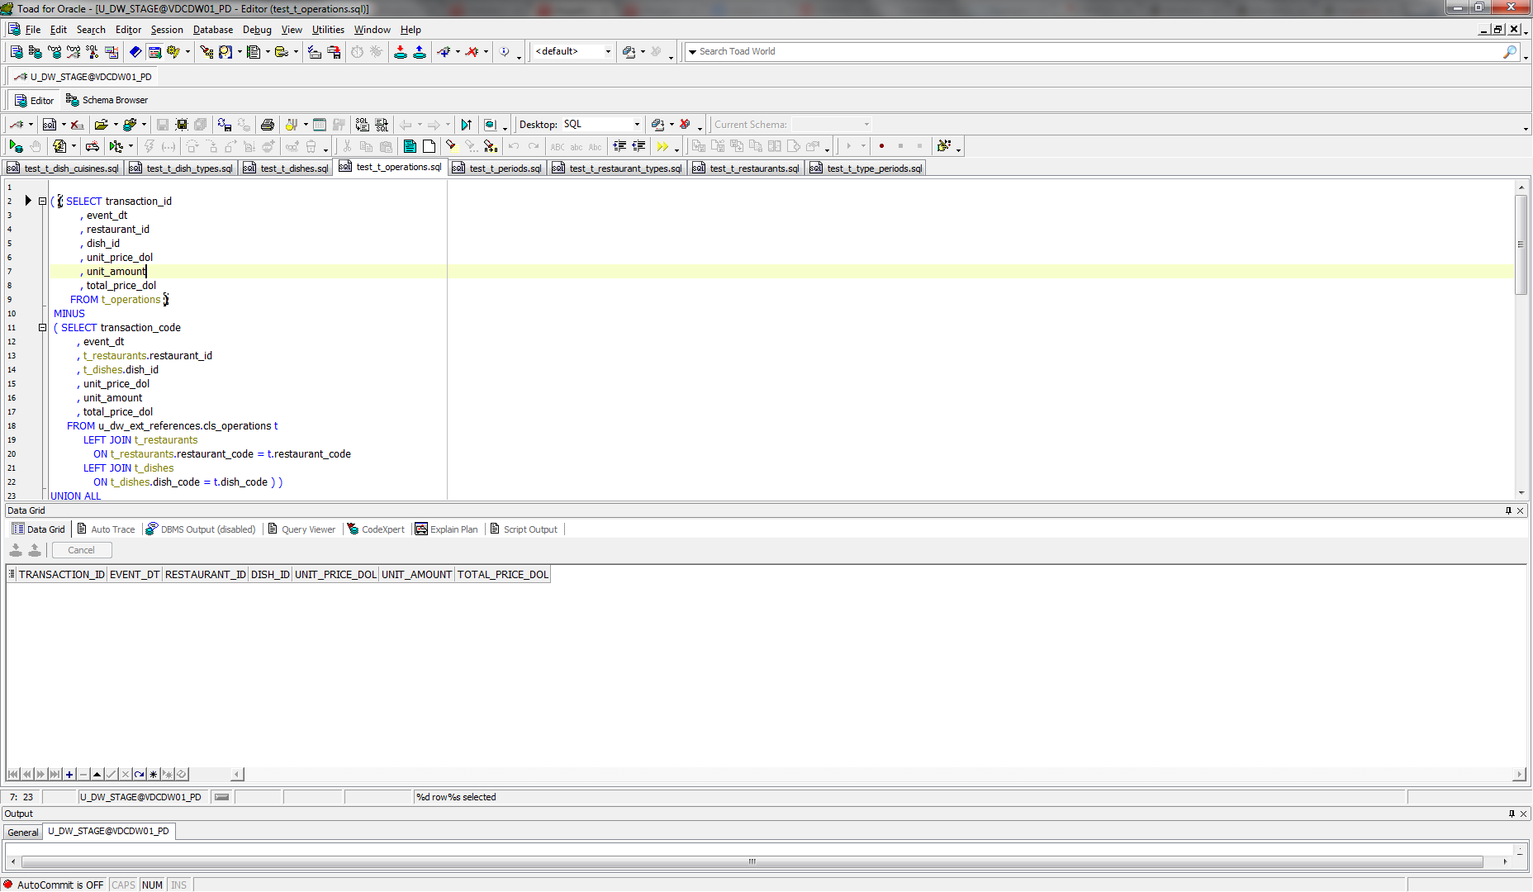

Table T_PERIODS:

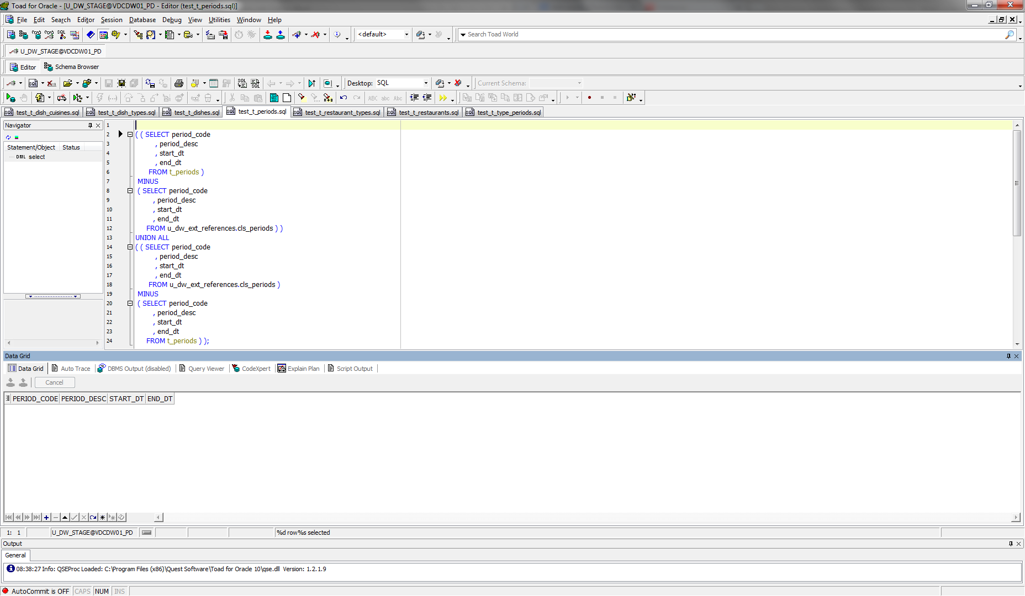

Table T_RESTAURANT_TYPES:

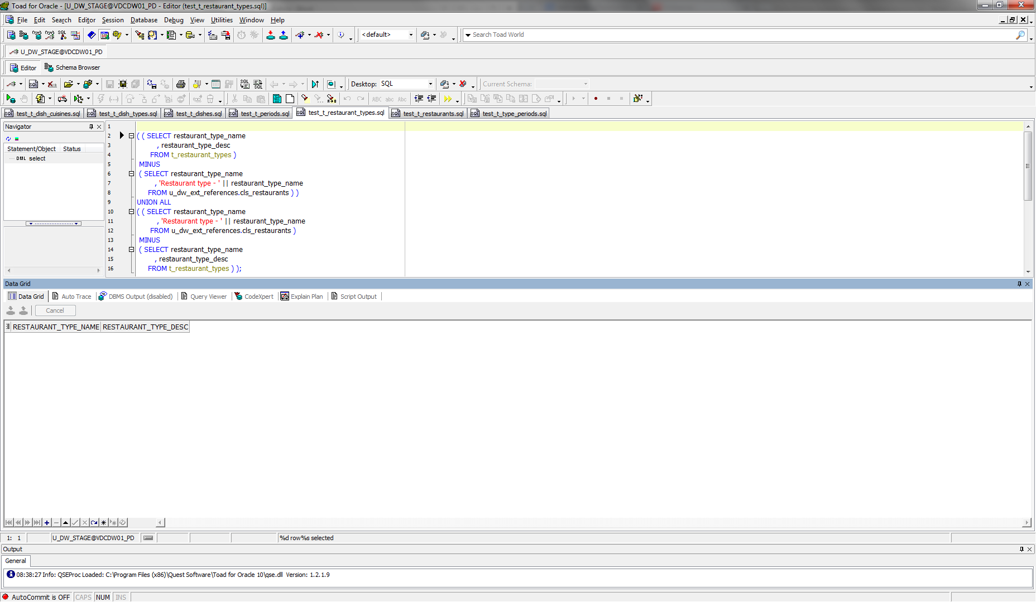

Table T_RESTAURANTS:

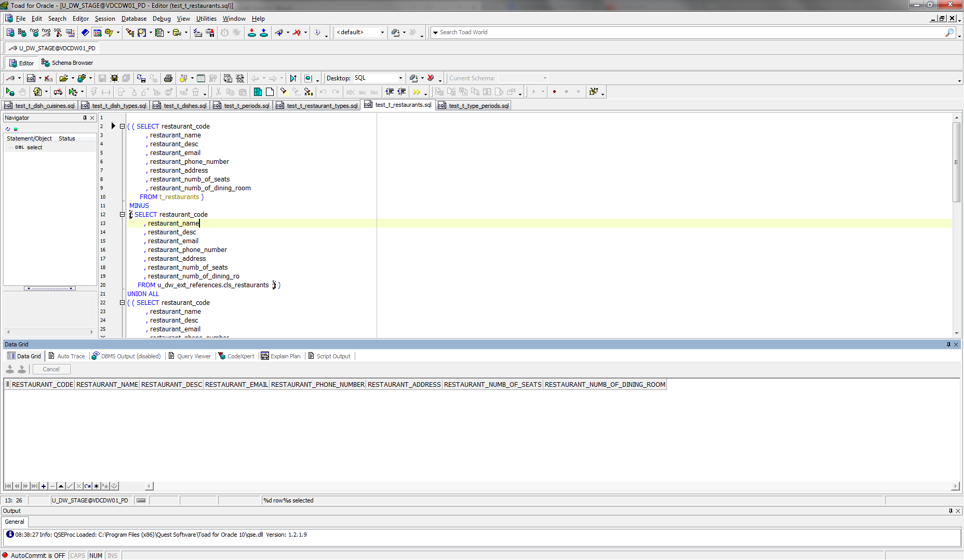

Table T_TYPE_PERIODS:

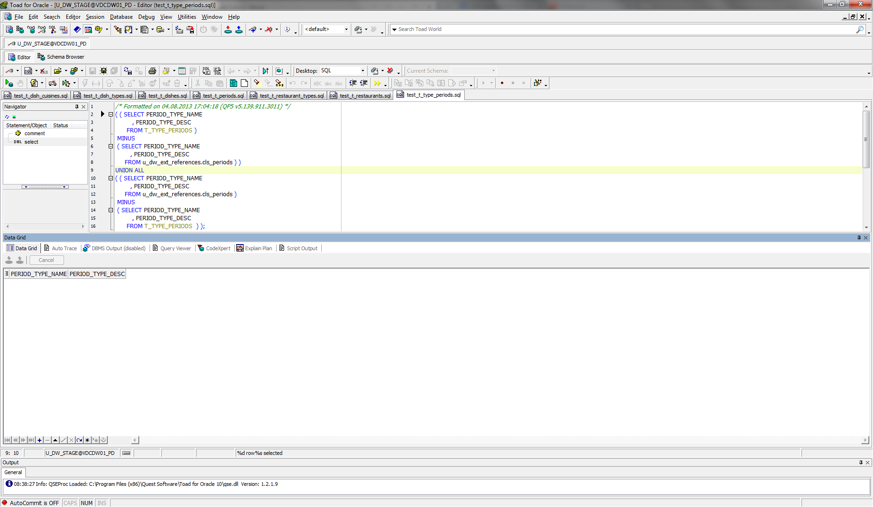

# Business analyses tasks – Reports

## Task 02: CREATE Monthly Reports Layouts

I have created Refactoring Adhoc SQL with using Module Clause.

Select necessary country and city (you can select all), month, the amount of dishes sold, the delta of dishes sold (the difference between the amounts of this and the previous month), the sales and delta of the sales (the difference between the sales of this and the previous month); display the total sums by the city, the country, all countries; sort by country in alphabetical order.

SELECT NVL ( country, 'Total' ) AS country

, NVL ( city, '-' ) AS city

, NVL ( TO_CHAR ( month_numb ), '-' ) AS number_of_month

, NVL ( month_name, '-' ) AS month_name

, TO_CHAR ( amount

, '9,999,999' )

AS amount

, NVL ( TO_CHAR ( delta_amount

, '9,999,999' )

, '-' )

AS delta_amount

, TO_CHAR ( total_sales

, '$999,999,999,999' )

AS total_sales

, NVL ( TO_CHAR ( delta_sales

, '$999,999,999,999' )

, '-' )

AS delta_sales

FROM ( SELECT country_name AS country

, city_name AS city

, month_numb

, month_name

, SUM ( amount ) AS amount

, delta_amount

, SUM ( total_price ) AS total_sales

, delta_sales

FROM (SELECT *

FROM ( SELECT TO_NUMBER ( TO_CHAR ( TRUNC ( oper.event_dt

, 'MONTH' )

, 'mm' ) )

AS month_numb

, TO_CHAR ( TRUNC ( oper.event_dt

, 'MONTH' )

, 'Month' )

AS month_name

, countries.region_desc AS country_name

, cities.city_desc AS city_name

, SUM ( oper.unit_amount ) AS amount

, SUM ( oper.total_price_dol ) AS total_price

FROM t_operations oper

LEFT JOIN t_restaurants rest

ON oper.restaurant_id = rest.restaurant_id

LEFT JOIN t_restaurant_types

ON rest.restaurant_type_id = t_restaurant_types.restaurant_type_id

LEFT JOIN t_dishes dishes

ON dishes.dish_id = oper.dish_id

LEFT JOIN t_dish_types

ON dishes.dish_type_id = t_dish_types.dish_type_id

LEFT JOIN t_dish_cuisines

ON dishes.dish_cuisine_id = t_dish_cuisines.dish_cuisine_id

LEFT JOIN u_dw_references.lc_cities cities

ON rest.restaurant_geo_id = cities.geo_id

LEFT JOIN u_dw_references.t_geo_object_links links

ON links.child_geo_id = cities.geo_id

LEFT JOIN u_dw_references.cu_countries countries

ON links.parent_geo_id = countries.geo_id

WHERE countries.region_desc IN ('United States of America')

AND cities.city_desc IN ('Hardy', 'Woodstock')

GROUP BY TO_NUMBER ( TO_CHAR ( TRUNC ( oper.event_dt

, 'MONTH' )

, 'mm' ) )

, TO_CHAR ( TRUNC ( oper.event_dt

, 'MONTH' )

, 'Month' )

, countries.region_desc

, cities.city_desc

ORDER BY TO_NUMBER ( TO_CHAR ( TRUNC ( oper.event_dt

, 'MONTH' )

, 'mm' ) )

, city_name)

MODEL RETURN UPDATED ROWS

PARTITION BY ( country_name, city_name )

DIMENSION BY ( month_numb )

MEASURES ( month_name, amount, 0 delta_amount, total_price, 0 delta_sales )

RULES AUTOMATIC ORDER

( delta_amount [month_numb] =

amount[CV ( month_numb )]

- NVL ( amount[CV ( month_numb ) - 1], amount[CV ( month_numb )] ),

delta_sales [month_numb] =

total_price[CV ( month_numb )]

- NVL ( total_price[CV ( month_numb ) - 1], total_price[CV ( month_numb )] ) ))

GROUP BY

ROLLUP (country_name, city_name, ( month_numb, month_name, delta_amount, delta_sales ) )

ORDER BY country_name

, city_name

, month_numb)

